How to Download Arduino IDE

Written by Aoife O’Sullivan

If you get stuck at any point, feel free to ask me or anyone else in the office! We’re all very friendly ☺

1. Go to <https://www.arduino.cc/en/Main/Software>
2. Click on Windows installer.

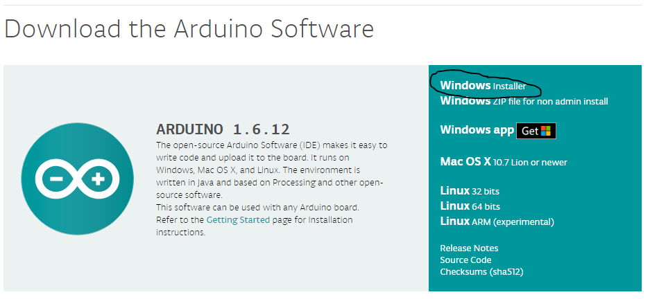

1. Click on Just Download.

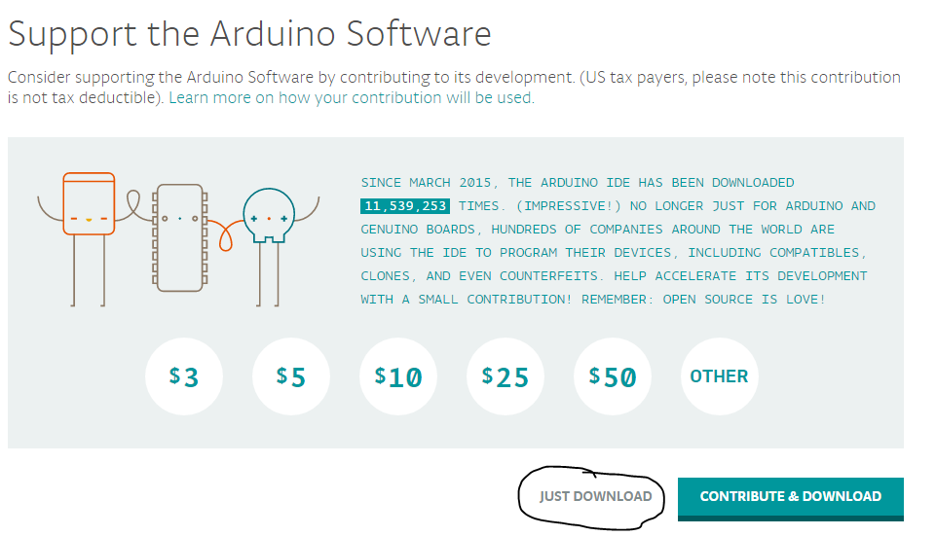

1. Wait for the file to download.
2. Find the file on your computer. It’s probably in the Downloads folder. If you can’t find it, do the following.
3. Click the Start button (Windows 7) or the Search button (Windows 10). Type in arduino.

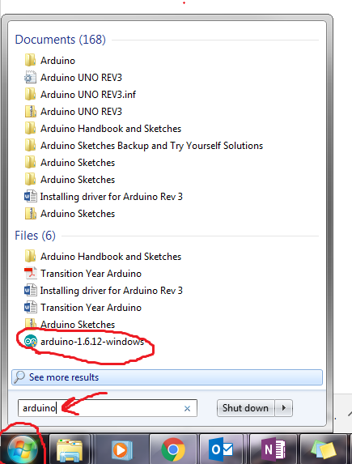

1. Once you have found the file, click on it to open the installer.
2. Click yes.

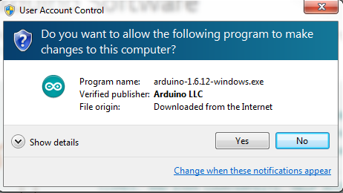

1. Click I Agree.

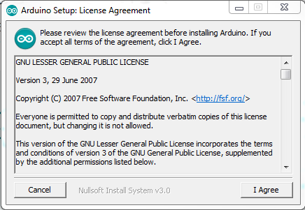

1. Make sure all the boxes are ticked. Click Next.

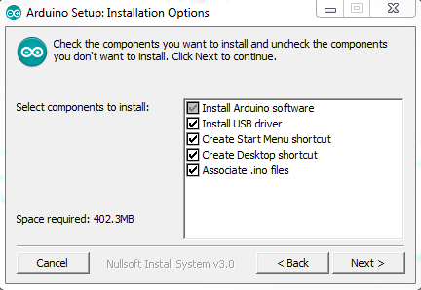

1. Click Install.

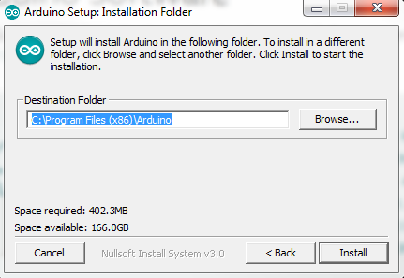

1. Wait for it to install.

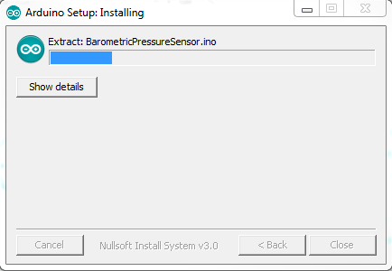

1. If this window pops up, check the box and click install.

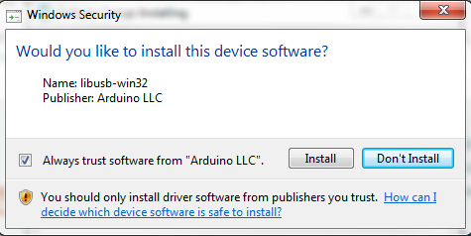

1. When it’s finished installing, you will see this. Click close.

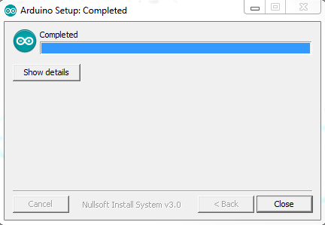

Next, find the document called “Installing driver for Arduino Rev 3” and follow the instructions. Again, if you get stuck, just ask! We don’t bite. ☺